Venue

The Fistf World Cup - Gibraltar 2018 will be played in the Tercentenary Sports Hall at Bayside Road. It is a minute’s walk from Ocean Village leisure area, three minutes from the town and 5 minutes away from the frontier. It provides an excellent playing area with fixed stands which can fit hundreds of family members and spectators. Toilets are beneath the stands and there is a small cafeteria at the entrance to the sports hall. The X marked on the picture below identifies the location of the venue.

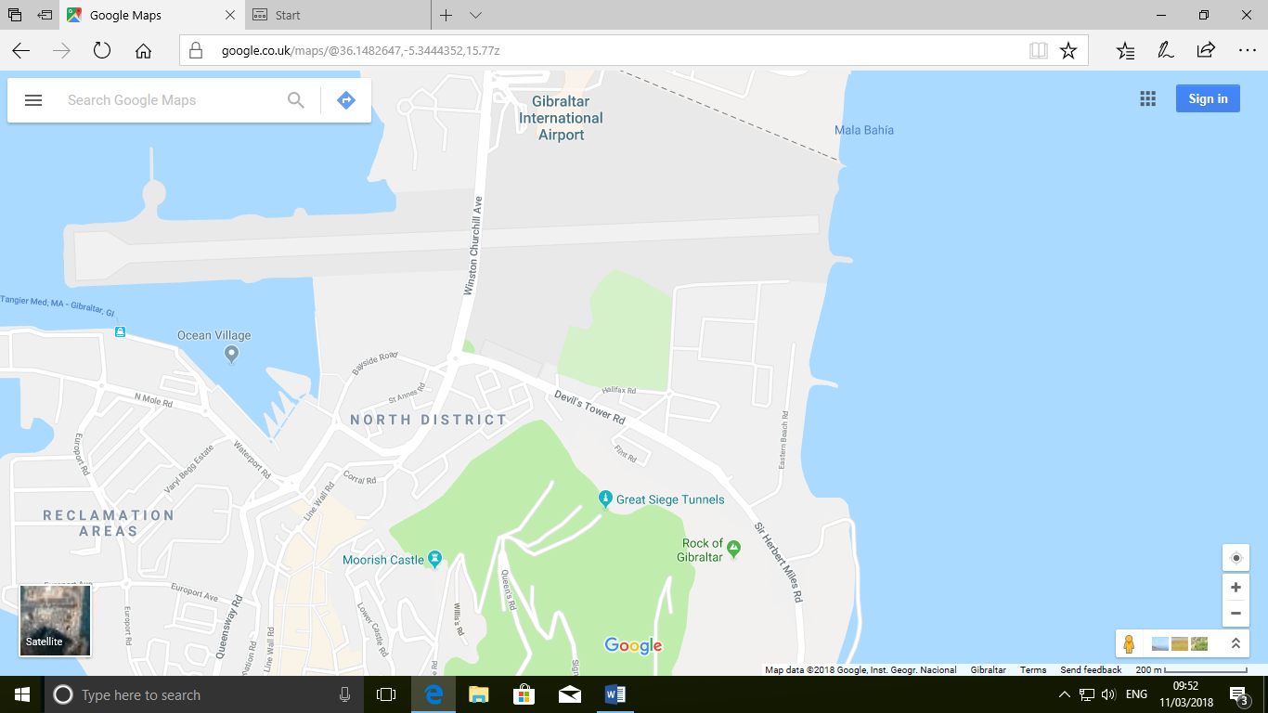
P

Parking
Parking slots for those who intend to arrive in vehicles is somewhat limited. I would suggest you park at either the Landport car park, Corral Road [yellow arrow] or the Devil’s Tower Road Car Park [green arrow].Both have fixed parking meters and are controlled by the hour by Parking Management Officers so make sure your ticket covers you for the time you are parked there to avoid unnecessary clamping. Both are within minutes walking from venue.

Other pictures

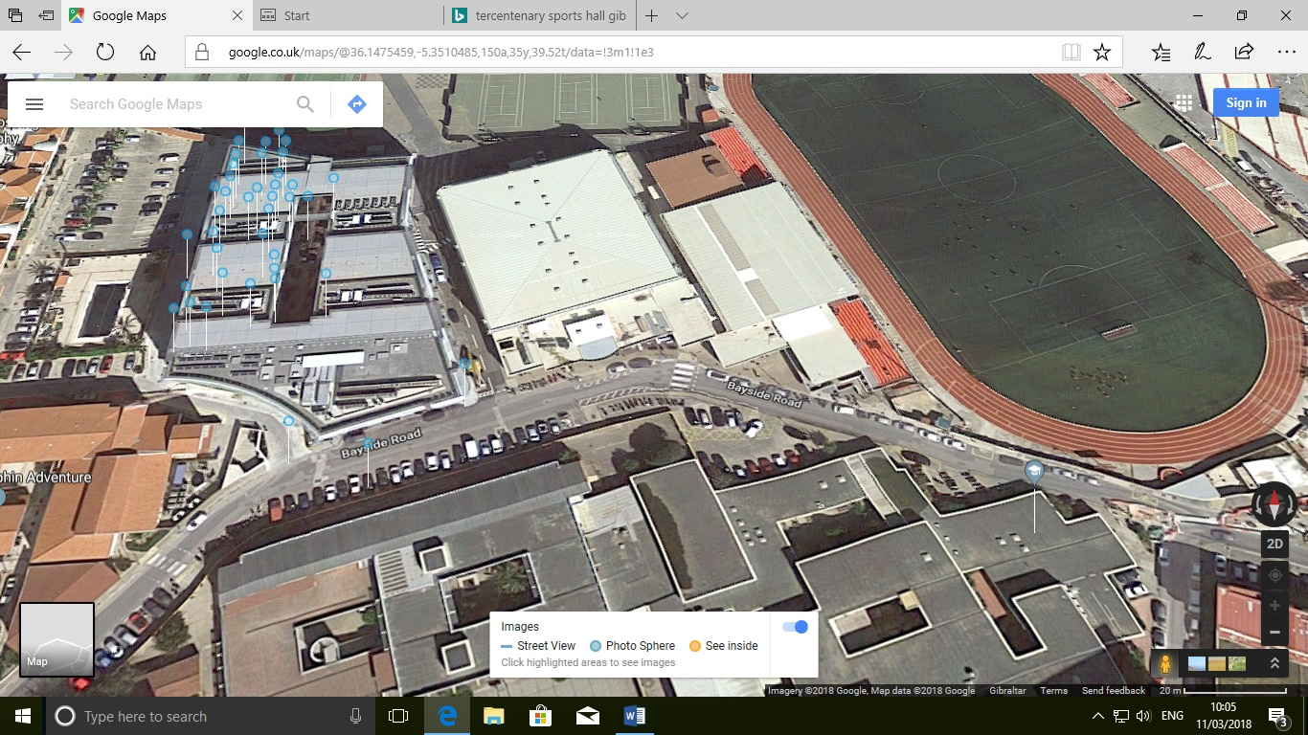

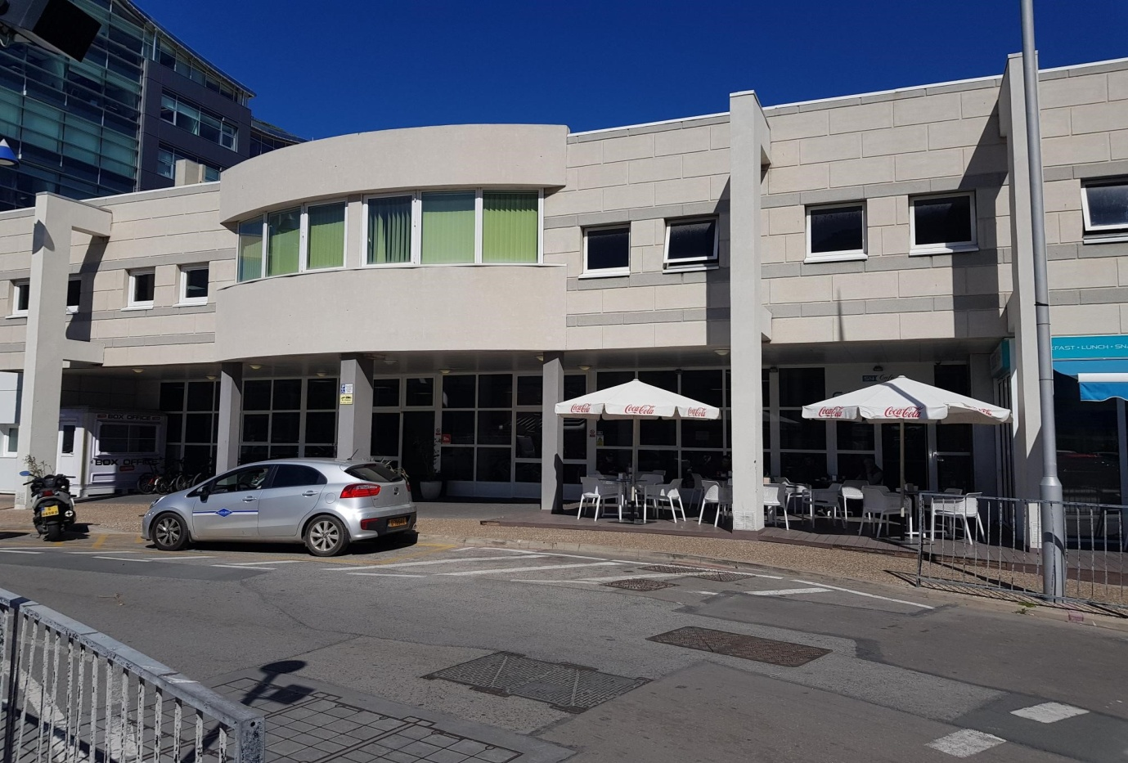
Entrance to sports hall
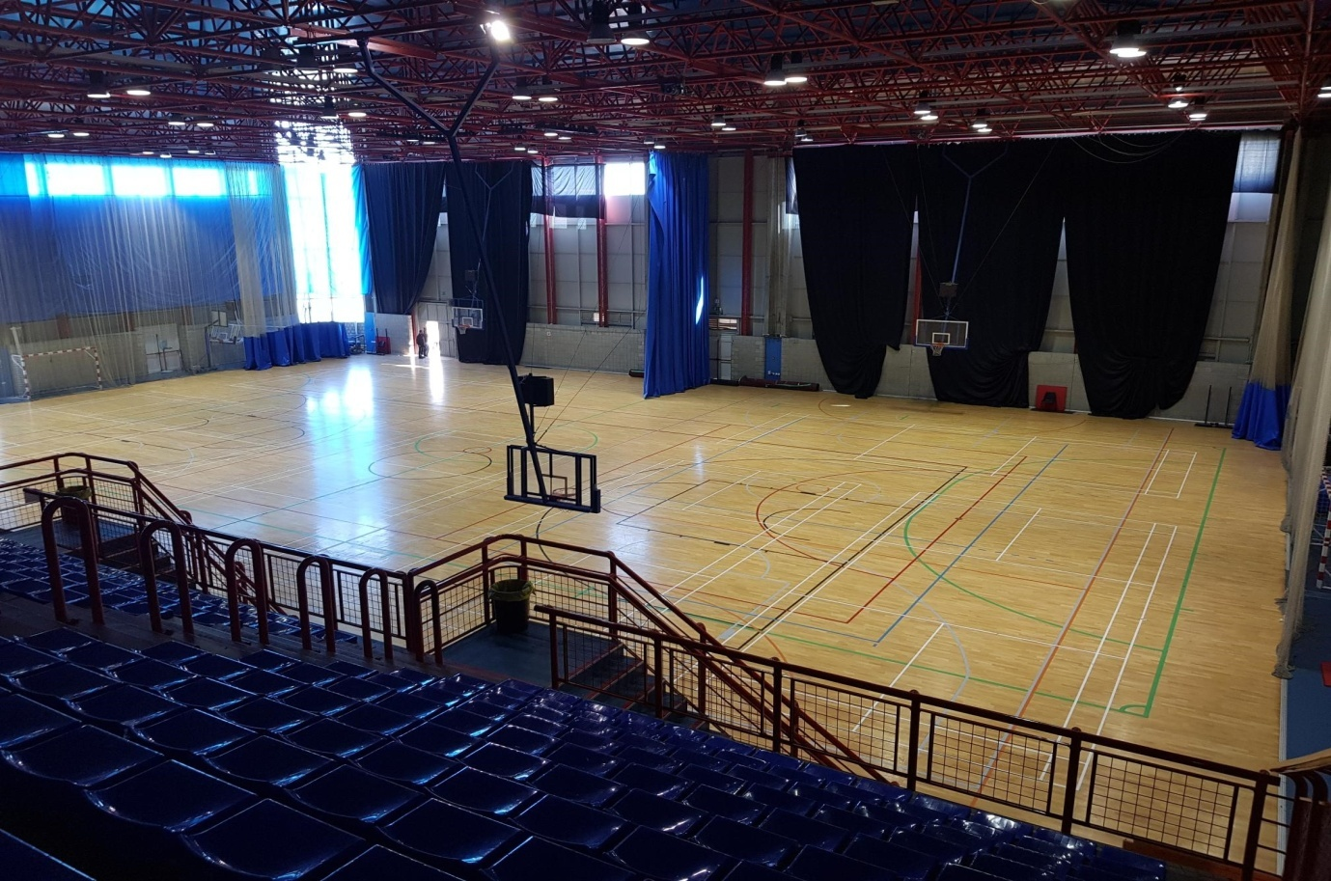
View from stands
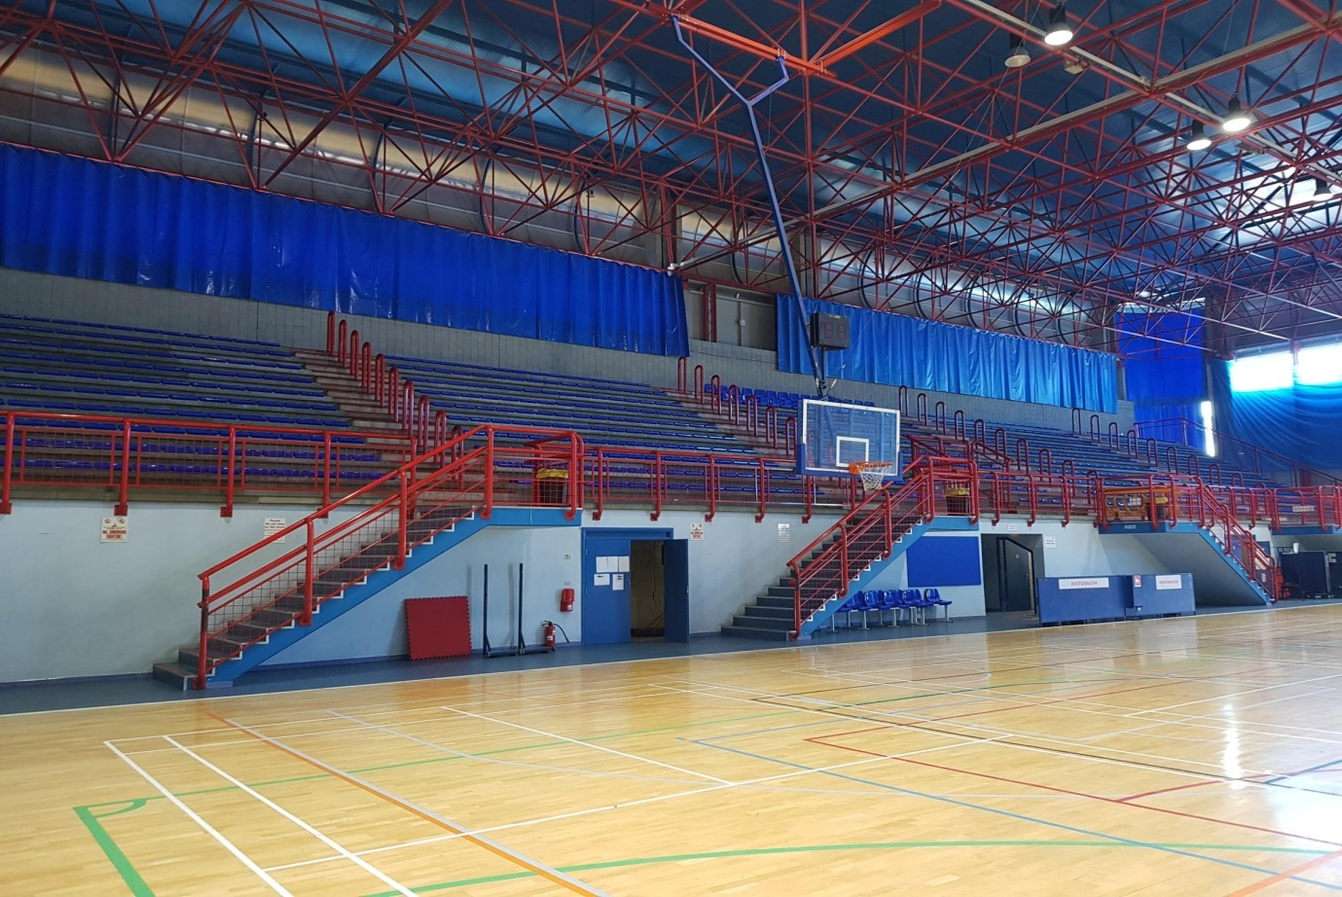
View from playing surface

